Assignment 1: Part 1
- A brief outline of the application

My application - MyRightHand (link to repository in Appendix 1) - is a digital phonebook that uses the command-line interface (CLI) to display information. Users can navigate menus by typing letters corresponding to the on-screen options. Users are able to perform the following actions within the application:
- Add a new contact (demonstrating insertion);
- View existing contacts (in alphabetical order by name, demonstrating sorting);
- Edit a contact (choosing to edit just the name, just the number, or both the name and number, demonstrating insertion);
- Delete a contact (demonstrating deletion);
- Search for a contact (demonstrating searching).
After searching and finding a contact, users can also choose to do the following:
- Edit the found contact (demonstrating insertion);
- Delete the found contact (demonstrating deletion).

The application executes by pressing ‘run’ and the above features are accessed by typing letters corresponding to the on-screen prompts (see flowcharts (i) (ii) (iii) to see these prompts on pages 3, 4, 5, and 12, respectively).

- Design of data structure and algorithms
The following numbered flowcharts demonstrate the data flow and data structures that the application utilises, following object-oriented programing. The first three flowcharts demonstrate how the three main menus function. These menus are instantiated from the Menu class, from which the ‘show_menu’ method is inherited. The methods called from the menus belong to the my_phonebook object that is instantiated from the Phonebook Class.

Key insertion, deletion, sorting, and searching algorithms are demonstrated within the following methods:

Insertion: (7) my_phonebook.insert_contact(self, name, number) [page 11]

Deletion: (3) my_phonebook.delete_contact(self) [page 10]

Sorting: (1a) my_phonebook.bubble_sort(self, contact_list) [page 7]

Searching: (2a) my_phonebook.binary_search(self) [page 9]

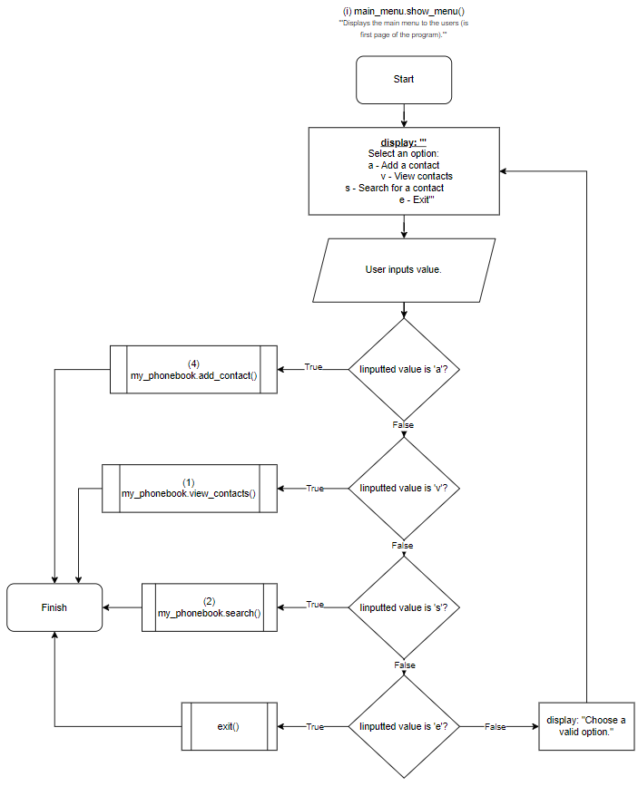

Idea for algorithm inspired by HyperionDev (2018).

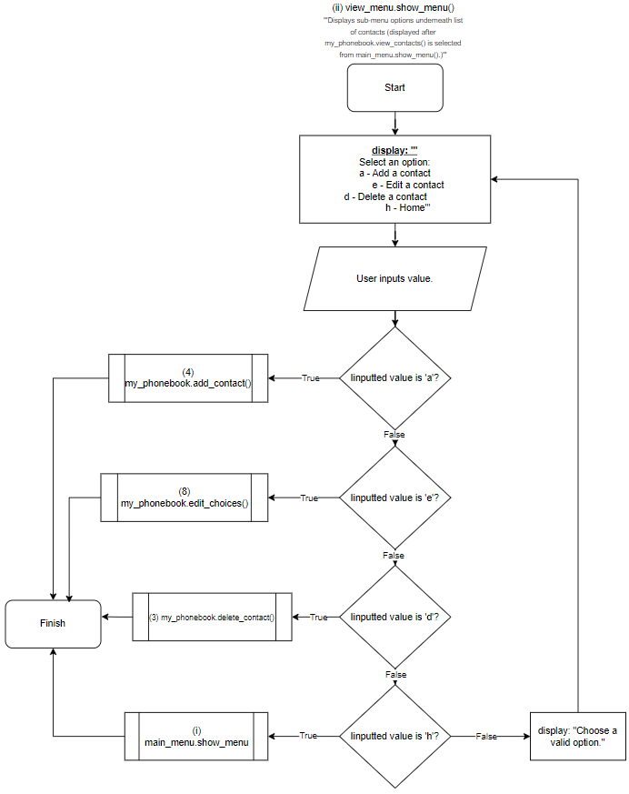

Idea for algorithm inspired by HyperionDev (2018).
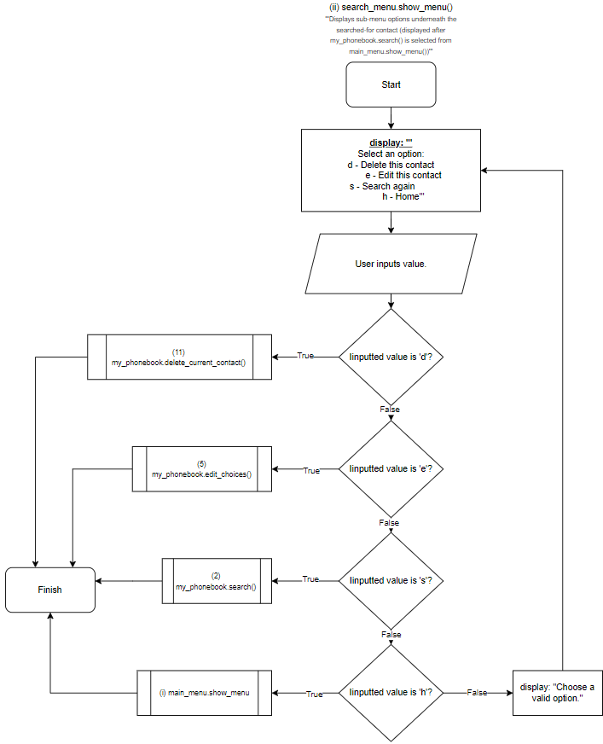

Idea for algorithm inspired by HyperionDev (2018).
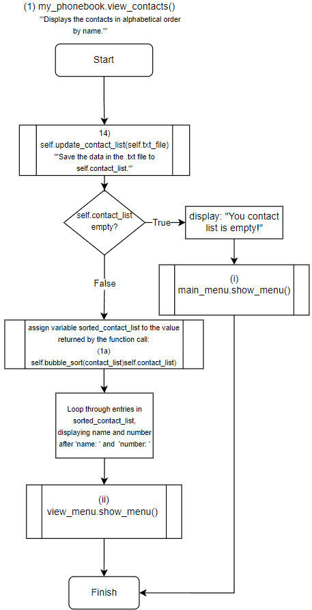

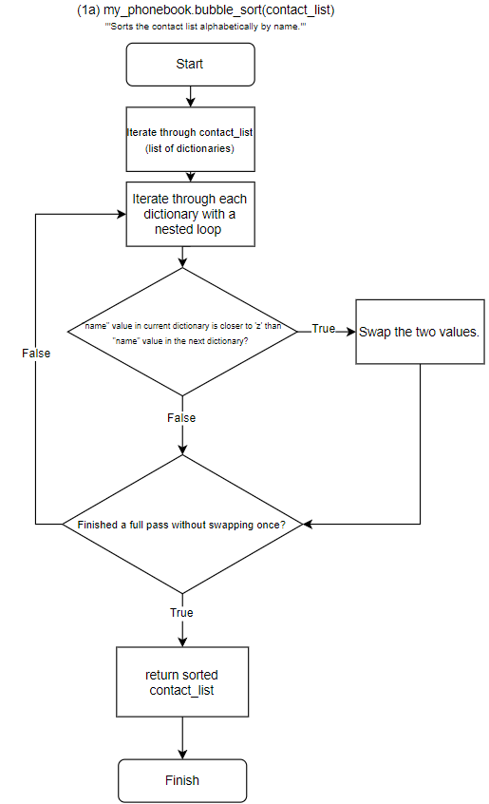

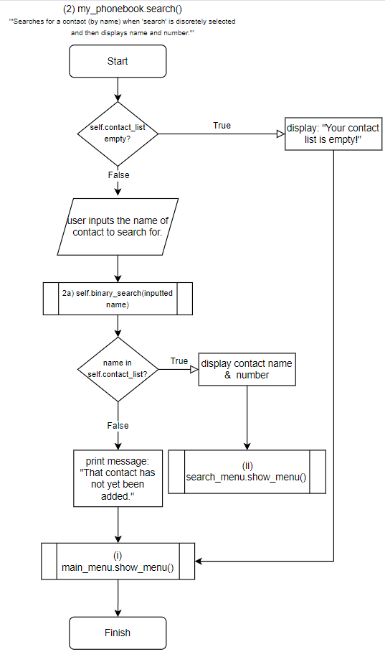

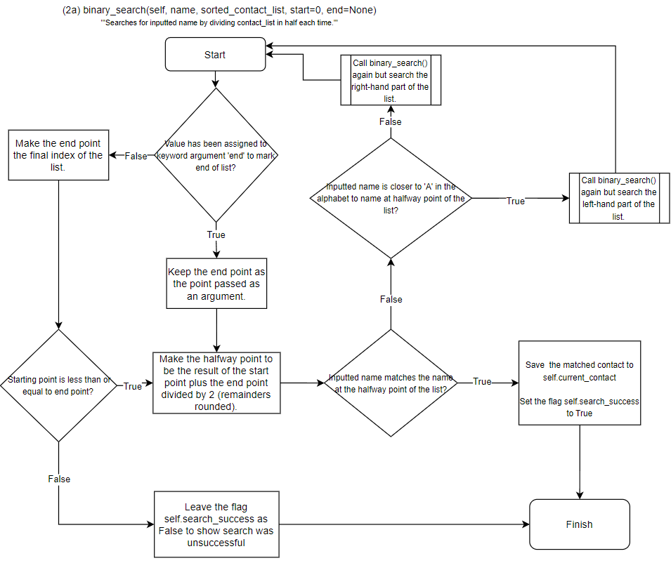

When prompted by the author with a question about a draft binary search algorithm, ChatGPT (OpenAI ChatGPT, 2024) responded with a suggested fix that this algorithm is based on. A copy of the prompt and response is in Appendix 1.
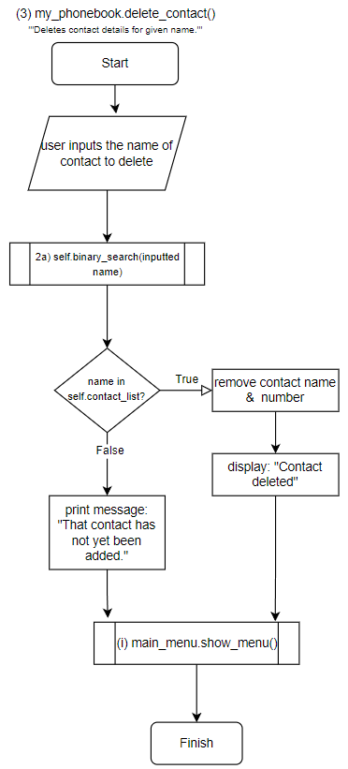

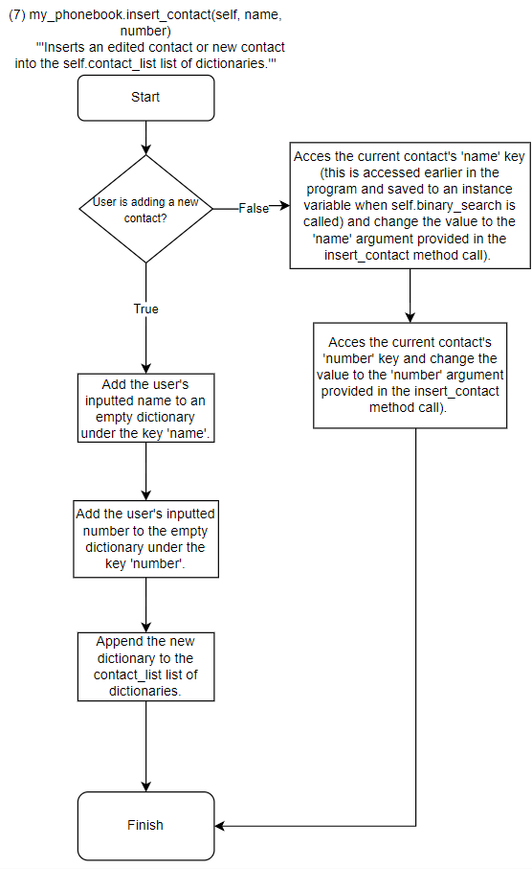

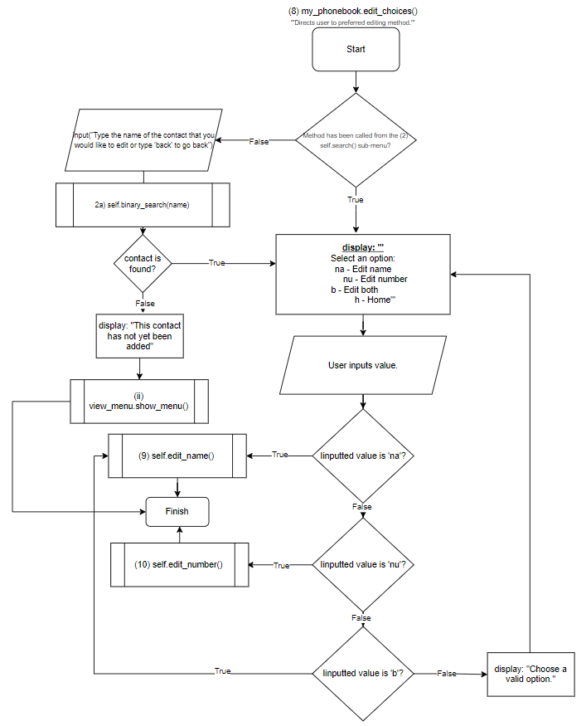

Idea for algorithm inspired by HyperionDev (2018).

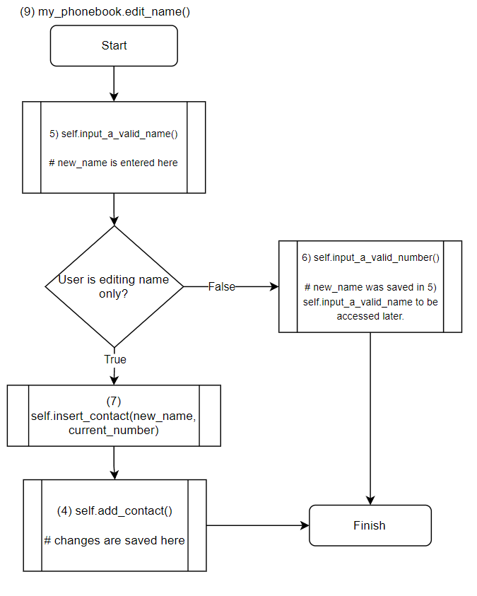

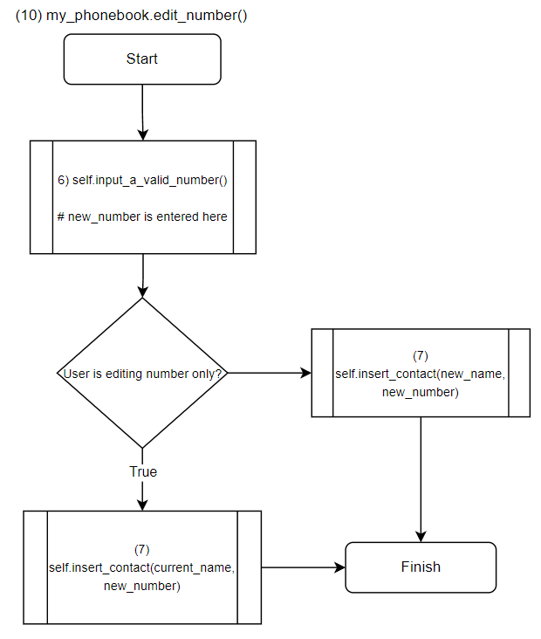

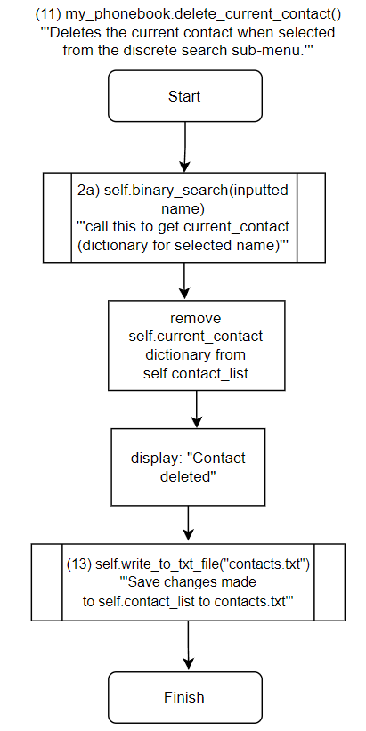

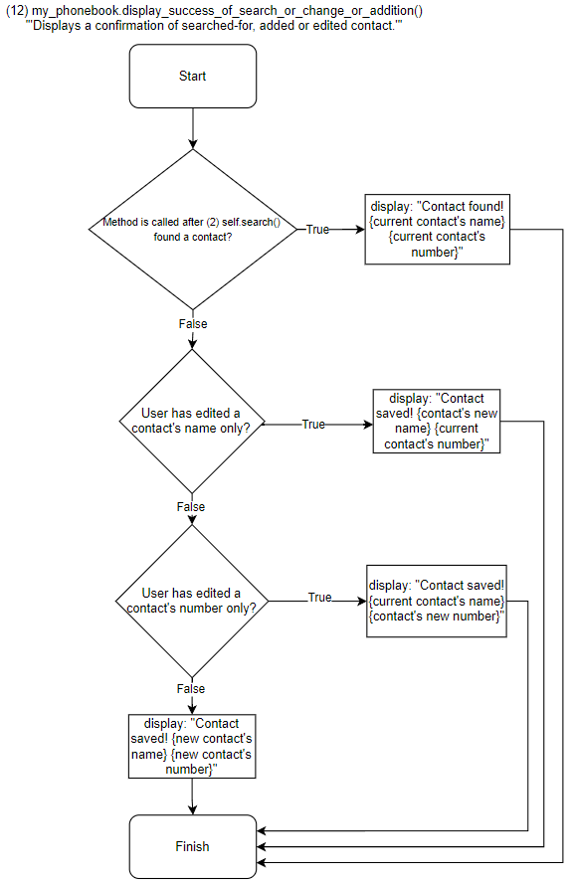

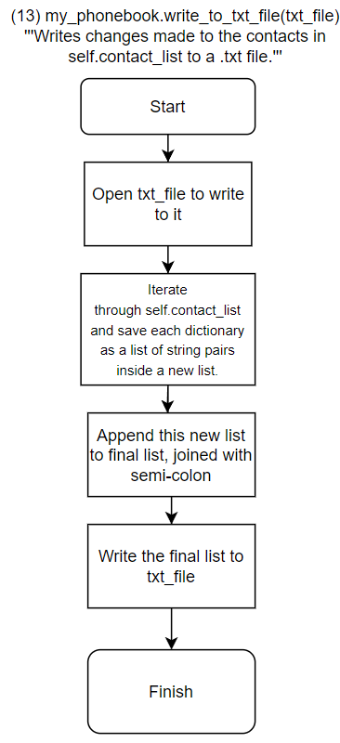

Idea for algorithm inspired by HyperionDev (2018).
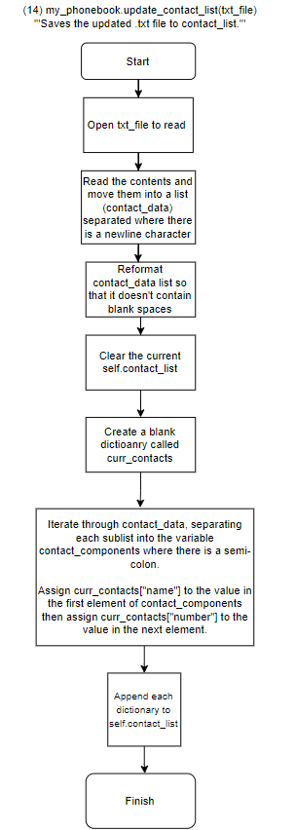

Idea for algorithm inspired by HyperionDev (2018).

- Test plan

STEP ID | DESCRIPTION | STEPS | INPUTS | EXPECTED RESULTS
1 | Insertion  Testing the ability to 'add a contact' by entering a name and number to add the new contact to the 'contacts.txt' file. | 1) Run program;  2) Type 'a' to add a contact;  3) Enter 'test' then press Enter when prompted for a name;  4) Enter 1234 then press Enter when prompted;  5) Repeat the above with following: name: Bob, number: 2345; name: Lisa, number: 3456; name: Bobby, number: 4567.  5) Type 'v' at the next menu to view contacts and check to see if the contact added is listed there;  6) Confirm that contact has saved to 'contacts.txt' by exiting the program and viewing the file. | test' (when prompted for name);  1234 (when prompted for number) | The following is visible after adding contact and typing 'v' to view contacts on subsequent menu:  'name: test  number: 1234'  The following is visible in contacts'txt file:  'test;1234'
2 | Sorting  Testing the ability of the 'view_contacts' function to sort the contacts in alphabetical order (by name). | 1) Run program;  2) Type 'v' to view contacts. | Type 'v' (when  prompted at first menu). | The following is visible (in this order):  'name: Bob  number: 2345  _______________  name: Bobby  number: 4567  _______________  name: Lisa  number: 3456  _______________  name: test  number: 1234'
3 | Deletion  Testing the ability to delete a valid name that is known to be saved in 'contacts.txt'. | 1) Run program;  2) Type 'd' to delete a contact;  3) Type 'test' then press Enter when prompted for the name of a contact to delete;  4) Press 'v' on the next menu to view contacts and check results. | new name' (when prompted for a name to delete) | The following is visible once the enter key is pressed:  ** Contact deleted **  The following is visible once 'v' is pressed on next menu:  'name: Bob  number: 2345  _______________  name: Bobby  number: 4567  _______________  name: Lisa  number: 3456  _______________'  The following is visible within contacts'txt file:  'Bob;2345  Lisa;3456  Bobby;4567'
4 | Searching  Testing the ability to search for a name that is known to be saved in 'contacts.txt'. | 1) Run program;  2) Type 's' to search contacts;  3) Type 'boBby' then press Enter when prompted for a name to search for. | boBby' (when prompted for a name to search for) | The following is visible once the name has been entered:  '** Contact found **  name: Bobby  number: 4567'

Conclusion
The key data structure within this application is a list of dictionaries (saved in the instance variable my_phonebook.contact_list). Each dictionary contains a record of the user’s name and number under a ‘name’ key and ‘number’ key respectively. The data from this dictionary is written to the ‘contacts.txt’ file – with each contact saved on a separate line, with name and number separated with a semicolon - at the end of a change brought about from insertion or deletion.

References
HyperionDev (2018) task_manager.py (Version 2018) [computer program]. Available at https://github.com/tedge85/task_manager/commit/b6cae61aa8668160ab21a7f68071c7a8d0e3482a (Downloaded: 18 December 2023).

OpenAIChatGPT (2024) ChatGPT response to Todd Edge [code]. Available at https://copilot.microsoft.com/sl/kXemM4MQPlI (Accessed: 20 June 2024).

Appendix 1
- my-right-hand repository:
https://github.com/tedge85/my-right-hand

- OpenAI ChatGPT (2024) prompt and response.

Prompt by author:

‘Why does this binary search keep repeating?

dict_list = [{"name": "Todd", "number": 1}, {"name": "Codd", "number": 1}, {"name": "Fodd", "number": 1}, {"name": "Lodd", "number": 1}, {"name": "Kodd", "number": 1}]

def bubble_sort(self, contact_list):
'''Sorts the contact list alphabetically by name.'''
swapped = False

n = len(contact_list)

for i in range(n):

# Nested loop to iterate through each dictionary, indexed as 'j'
for j in range(0, n-i-1):

# Variables for name values in dictionaries next to each other in contact_list.
name1 = contact_list[j]["name"]
name2 = contact_list[j+1]["name"]

# Swap contact order if name value closer to 'a' in alphabet.
if name1 > name2:

contact_list[j], contact_list[j+1] = contact_list[j+1], contact_list[j]
swapped = True

# Exit outer loop and stop comparing if single swap not made (i.e. list already in order).
if not swapped:
break

return contact_list

def binary_search(name, contact_list):

# Iterate through list to match, divide each time by indexing, recursion
halfway = round(len(contact_list)/2 -1)
end = len(contact_list)
print(halfway)
print(contact_list)

if halfway >= 0: if contact_list[halfway]["name"].lower() == name.lower():
print("search success")
elif contact_list[halfway]["name"].lower() > name.lower():
new_list = contact_list[:halfway]
binary_search(name, new_list)
elif contact_list[halfway]["name"].lower() < name.lower():
new_list = contact_list[halfway:end]
binary_search(name, new_list)
else: print("search fail")

sorted_list = bubble_sort(dict_list) binary_search("Todd", sorted_list)’

Response from OpenAI ChatGPT:
The issue with the binary search function is that it does not correctly update the range of the list to search through after each recursive call. Specifically, when the search continues in the upper half of the list, it should not include the halfway index again, as this can cause an infinite loop if the halfway index is where the search term is found or if there’s no change in the index due to rounding.
Here’s how you can fix it:
Python
def binary_search(name, contact_list, start=0, end=None):
if end is None:
end = len(contact_list) - 1

if start <= end:
halfway = (start + end) // 2 # Use integer division to avoid floating-point indices
print(halfway)
print(contact_list[start:end+1]) # Print the current range being searched

if contact_list[halfway]["name"].lower() == name.lower():
print("search success")
return halfway # Return the index if found

elif contact_list[halfway]["name"].lower() > name.lower():
return binary_search(name, contact_list, start, halfway - 1) # Search in the left half
else:
return binary_search(name, contact_list, halfway + 1, end) # Search in the right half
else:
print("search fail")
return None # Return None if not found
AI-generated code. Review and use carefully. More info on FAQ.
In this revised version of binary_search, I’ve added start and end parameters to keep track of the current range being searched. This ensures that with each recursive call, the function searches a smaller section of the list until it finds the target or determines that it’s not present. Also, I’ve used integer division (//) for calculating halfway to ensure we get an integer index. Give this updated function a try! 🐍🔍

Assignment 1: Part 2
Testing strategy
The first set of tests (see Part 1: initial tests of normal data) tests the ability of the ‘add contact’ unput to insert data; the ability of the ‘view contacts’ input to sort data; the ability of the ‘search contacts’ input to search through data; and the ability of the ‘delete a contact’ input to delete data.

The second set of tests (see Part 2: Application functionality tests) uses normal, extreme, boundary and exceptional data for each menu option, to test whether or not the program responds with appropriate displayed messages.

README
MyRightHand is a digital phonebook app in which you can add, view, store, edit, delete and search for contacts. This project aims to demonstrate insertion, sorting, deletion and searching.

Prerequisites
- Download Jupyter Notebook

Installation
$ Open Jupyter Notebook;
$ Upload the file ‘my-right-hand.ipynb’
$ Double click on the file in Jupyter Notebook once uploaded.
$ Once opened, click in the first cell then select ‘run’.

Usage
Navigate the program by typing the given options displayed on screen. Upon starting the program, you will be presented with the following menu screen:
$ Main menu: 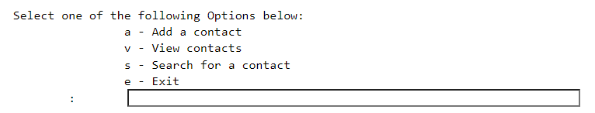
- To add a new contact, type ‘a’ in the input box.
- To see your current saved contacts displayed in alphabetical order (by name), type ‘v’ in the input box.
- To search for an existing contact and see his/her name and number displayed, type ‘s’ in the input box.
- To exit the program, type ‘e’ in the input box.

a – Add a contact
If you selected ‘a’ in the main menu above, you will be presented with the following:
Make sure to only enter a contact name (or 2 names – first and second) using 20 letters or fewer.

If your name input is valid, you will be presented with the following:
Make sure to only enter a number using 11 digits or fewer.

If your number input is valid, you will be presented with the following (with ‘a’ replaced with your chosen name and ‘11’ replaced with your chosen number):
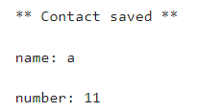

v – View contacts
If you selected ‘v’ in the main menu above, your existing contacts will be displayed in alphabetical order (by name), if you have previously added contacts. For example: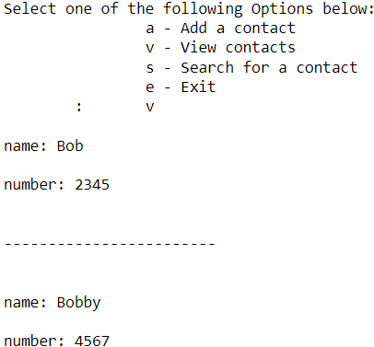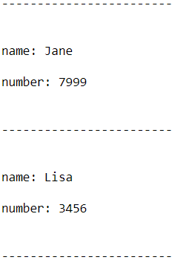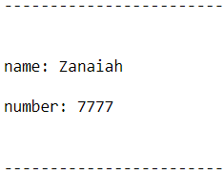
However, if you are yet to add a contact, you will be presented with the following:
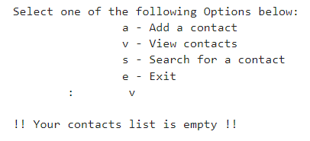

If you have at least one contact saved, after selecting the ‘view’ option, you will see the following menu displayed below the listed contact(s):

$ View menu: 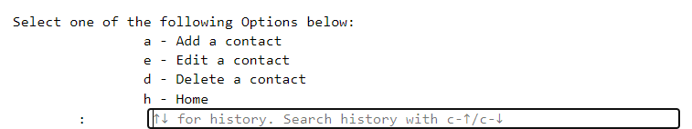
If you type ‘a’, this is the same as selecting a from the main menu (see a – Add a contact section above).

If you type ‘e’, you will be presented with the following:

If the contact has not yet been added within the program, you will be presented with the following:
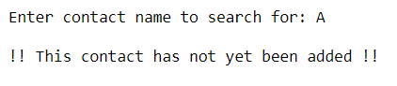
If the contact has been added within the program, you will be presented with the following:
$ Edit menu:

If you select ‘na’ to edit just the name, you will be presented with the following:
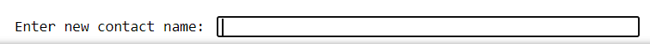
Make sure to only enter a contact name (or 2 names – first and second) using 20 letters or fewer.

If your name input is valid, the following will be displayed:
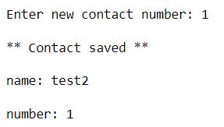
name: new name
number: original number

If you select ‘nu’ to edit just the number, you will be presented with the following:
Make sure to only enter a number using 11 digits or fewer.
If your number input is valid, the following will be displayed:
name: original name
number: new number

If you select ‘b’ to edit both the name and number, you will be presented with the following:
Make sure to only enter a contact name (or 2 names – first and second) using 20 letters or fewer.

If you enter a valid contact name, you will be presented with the following:
Make sure to only enter a number using 11 digits or fewer.

If your number input is valid, the following will be displayed:
name: new name
number: new number
s – Search
If you selected ‘s’ in the main menu, you will be presented with the following:
Make sure to only enter a contact name (or 2 names – first and second) using 20 letters or fewer.

If you enter a valid name that has already been added in the program, you will be presented with the following:
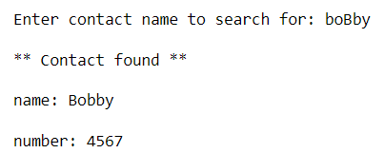
name: found name
number: found number

Underneath this confirmation, you will be presented with the following menu:
$ Search menu:
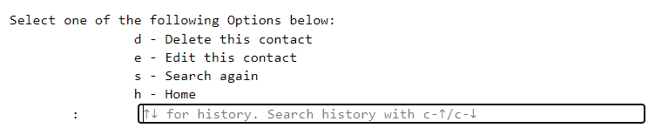

If you select ‘d’, you will delete the searched for contact and will be presented with the following:
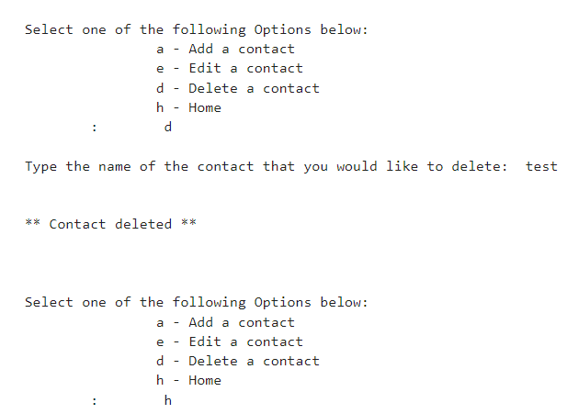
If you select ‘e’, you will be presented with the edit menu (see $ Edit menu above).

If you select ‘s’, you will be presented with the search prompt (see above).
If you select ‘h’, you will return to the $ Main menu (see above).

Tech stack
Python 3

References (see citations in code comments)
HyperionDev (2018) task_manager.py (Version 2018) [computer program]. Available at https://github.com/tedge85/task_manager/commit/b6cae61aa8668160ab21a7f68071c7a8d0e3482a (Downloaded: 18 December 2023).

OpenAI ChatGPT (2024) ChatGPT response to author [code]. Available at https://copilot.microsoft.com/sl/kXemM4MQPlI (Accessed: 20 June 2024).

Appendix 2
OpenAI ChatGPT (2024) prompt and response.

Prompt by author:

‘Why does this binary search keep repeating?

dict_list = [{"name": "Todd", "number": 1}, {"name": "Codd", "number": 1}, {"name": "Fodd", "number": 1}, {"name": "Lodd", "number": 1}, {"name": "Kodd", "number": 1}]

def bubble_sort(self, contact_list):
'''Sorts the contact list alphabetically by name.'''
swapped = False

n = len(contact_list)

for i in range(n):

# Nested loop to iterate through each dictionary, indexed as 'j'
for j in range(0, n-i-1):

# Variables for name values in dictionaries next to each other in contact_list.
name1 = contact_list[j]["name"]
name2 = contact_list[j+1]["name"]

# Swap contact order if name value closer to 'a' in alphabet.
if name1 > name2:

contact_list[j], contact_list[j+1] = contact_list[j+1], contact_list[j]
swapped = True

# Exit outer loop and stop comparing if single swap not made (i.e. list already in order).
if not swapped:
break

return contact_list

def binary_search(name, contact_list):

# Iterate through list to match, divide each time by indexing, recursion
halfway = round(len(contact_list)/2 -1)
end = len(contact_list)
print(halfway)
print(contact_list)

if halfway >= 0: if contact_list[halfway]["name"].lower() == name.lower():
print("search success")
elif contact_list[halfway]["name"].lower() > name.lower():
new_list = contact_list[:halfway]
binary_search(name, new_list)
elif contact_list[halfway]["name"].lower() < name.lower():
new_list = contact_list[halfway:end]
binary_search(name, new_list)
else: print("search fail")

sorted_list = bubble_sort(dict_list) binary_search("Todd", sorted_list)’

Response from OpenAI ChatGPT:
The issue with the binary search function is that it does not correctly update the range of the list to search through after each recursive call. Specifically, when the search continues in the upper half of the list, it should not include the halfway index again, as this can cause an infinite loop if the halfway index is where the search term is found or if there’s no change in the index due to rounding.
Here’s how you can fix it:
Python
def binary_search(name, contact_list, start=0, end=None):
if end is None:
end = len(contact_list) - 1

if start <= end:
halfway = (start + end) // 2 # Use integer division to avoid floating-point indices
print(halfway)
print(contact_list[start:end+1]) # Print the current range being searched

if contact_list[halfway]["name"].lower() == name.lower():
print("search success")
return halfway # Return the index if found

elif contact_list[halfway]["name"].lower() > name.lower():
return binary_search(name, contact_list, start, halfway - 1) # Search in the left half
else:
return binary_search(name, contact_list, halfway + 1, end) # Search in the right half
else:
print("search fail")
return None # Return None if not found
AI-generated code. Review and use carefully. More info on FAQ.
In this revised version of binary_search, I’ve added start and end parameters to keep track of the current range being searched. This ensures that with each recursive call, the function searches a smaller section of the list until it finds the target or determines that it’s not present. Also, I’ve used integer division (//) for calculating halfway to ensure we get an integer index. Give this updated function a try! 🐍🔍

Testing and validation
Part 1: initial tests of normal data
Corrections to original test plan in Assignment 1 Part 1 made in red
STEP ID | DESCRIPTION | INPUTS | EXPECTED RESULTS | ACTUAL RESULTS
1 | Insertion  [normal] Testing the ability to 'add a contact' by entering a name and number to add the new contact to the 'contacts.txt' file. | test' (when prompted for name);  1234 (when prompted for number) | The following is visible after adding the first contact and typing 'v' to view contacts on subsequent menu:  'name: test  number: 1234'  The following is visible in contacts'txt file after first entry added:  'test;1234'  The following is visible in contacts.txt file after adding all names:  Bob;2345  Lisa;3456  test;1234  Bobby;4567 | PASS
2 | Sorting  [normal] Testing the ability of the 'view_contacts' function to sort the contacts in alphabetical order (by name). | Type 'v' (when  prompted at first menu). | The following is visible (in this order):  'name: Bob  number: 2345  _______________  name: Bobby  number: 4567  _______________  name: Lisa  number: 3456  _______________  name: test  number: 1234' | PASS
3 | Deletion  [normal] Testing the ability to delete a valid name that is known to be saved in 'contacts.txt'. | new name' (when prompted for a name to delete) | The following is visible once the enter key is pressed:  ** Contact deleted **  The following is visible once 'v' is pressed on next menu:  'name: Bob  number: 2345  _______________  name: Bobby  number: 4567  _______________  name: Lisa  number: 3456  _______________'  The following is visible within contacts'txt file:  'Bob;2345  Lisa;3456  Bobby;4567' | PASS
4 | Searching  [normal] Testing the ability to search for a name that is known to be saved in 'contacts.txt'. | boBby' (when prompted for a name to search for) | The following is visible once the name has been entered:  '** Contact found **  name: Bobby  number: 4567' | PASS

Screenshot Evidence
1
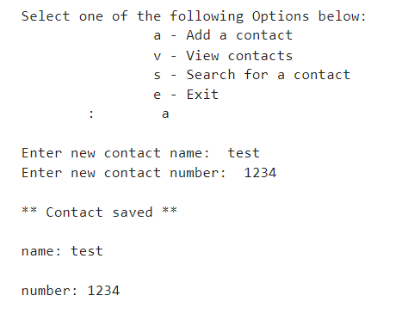
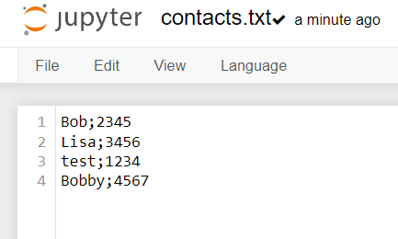
2
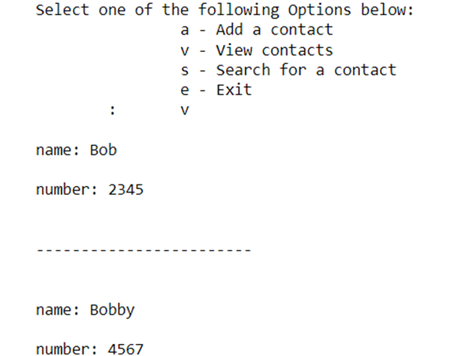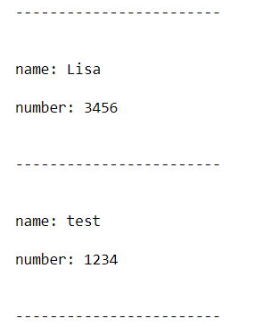
3

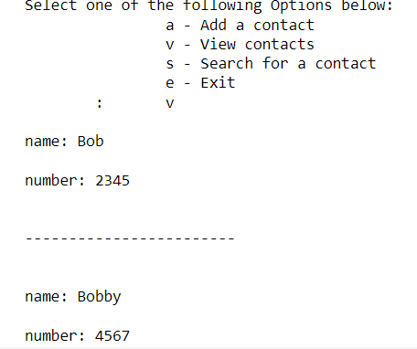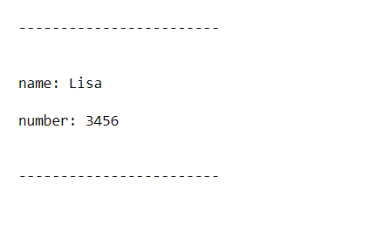
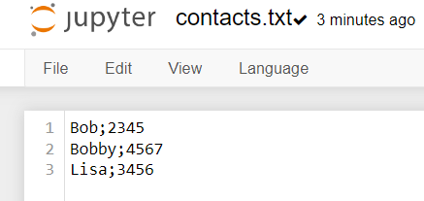

4
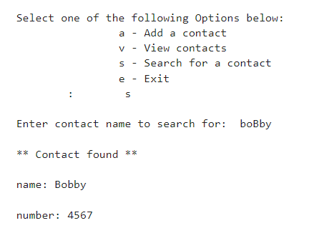
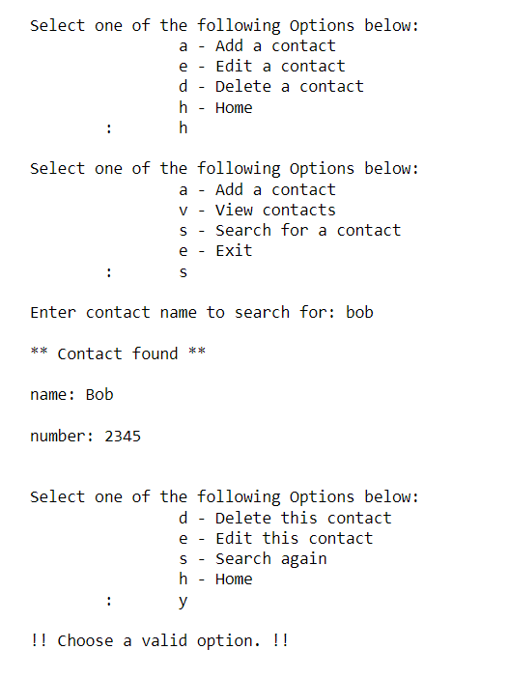

Part 2: Application functionality tests

STEP ID | DESCRIPTION | INPUT | EXPECTED RESULTS | ACTUAL RESULTS
MENU 1 | [exceptional] Verify error message when invalid choice typed in each menu (main menu, view menu, search menu, edit choices menu). | x  v  z  h  s  bob  y | The following is  visible  after entering 'x', 'z', 'y':  !! Choose a valid option !! | PASS
ADD  CONTACT 2 | [normal] Testing the ability to add 5 contacts by entering a name and number to add the new contact to the 'contacts.txt' file. | Jane' (when prompted for name);  7999 (when prompted for number)  'Zanaiah' (when prompted for name);  7777 (when prompted for number | Once added to the existing contacts, the following is visible after typing 'v' to view contacts on subsequent menu:  'name: Bob  number: 2345  _______________  name: Bobby  number: 4567  _______________  name: Jane  number: 7999  _______________  name: Lisa  number: 3456  _______________  name: Zanaiah  number: 7777  _______________  The following is visible in contacts'txt file:  Bob;2345  Bobby;4567  Jane;7999  Lisa;3456  Zanaiah;7777 | PASS
ADD  CONTACT 3 | [boundary] Verify error message when name entered is too long - 21 (boundary case) when prompted for 'add contact' option. | ‘abcdefghijklmnopqrstu' | The following is visible:  !! You have entered too many characters. Try again !! | PASS
ADD  CONTACT 4 | [boundary] Verify error message when no name entered when prompted for 'add contact' option. | BLANK | The following is visible:  !! You did not enter a name. Try again !! | PASS
ADD  CONTACT 5 | [extreme] Verify name can be added when it is a maximum number of characters when prompted for 'add contact' option. | abcdefghijklmnopqrst' | The following is  visible:  'Enter number:' | PASS
ADD  CONTACT 6 | [extreme] Verify name can be added when it is one character long when prompted for 'add contact' option. | a | The following is  visible:  'Enter number:' | PASS
ADD  CONTACT 7 | [exceptional] Verify error message when name entered is a space. | SPACEBAR | The following is  visible:  !! You did not enter a name. Try again !!!! | PASS
ADD  CONTACT 8 | [exceptional] Verify error message when name entered is two names with many spaces between when prompted for 'add contact' option. | test this' (20 spaces between) | The following is  visible:  !! You have entered too many characters. Try again !! | PASS
ADD  CONTACT 9 | [exceptional] Verify error message when name entered is integer when prompted for 'add contact' option. | 1 | The following is  visible:  !! You need to enter a name, not a number !! | PASS
ADD  CONTACT 10 | [exceptional] Verify error message when name entered is float when prompted for 'add contact' option. | 1.1 | The following is  visible:  !! You need to enter a name, not a number !! | PASS
ADD  CONTACT 11 | [exceptional] Verify error message when name entered is a special character when prompted for 'add contact' option. | £ | The following is  visible:  '!! You need to enter a name using letters !!' | PASS
ADD CONTACT 12 | [exceptional] Verify duplicate names cannot be added when prompted for 'add contact' option. | Lisa' | The following is  visible:  '!! This contact already exists. Pick a different name !!' | PASS
ADD  CONTACT 13 | [exceptional] Verify disallowed name cannot be added when prompted for 'add contact' option. | back' | The following is  visible:  '!! This is a menu option so can't be used as a name - that's just confusing !!' | PASS
ADD  CONTACT 14 | [boundary] Verify error message when number entered is too long - 12 (boundary case) when prompted for 'add contact' option. | 123456789111' | The following is  visible:  !! You have entered too many digits. Try again !! | PASS
ADD  CONTACT 15 | [boundary] Verify error message when no number entered when prompted for 'add contact' option. | BLANK | The following is  visible:  !! You did not enter a number. Try again !! | PASS
ADD CONTACT 16 | [extreme] Verify name can be added when it is a maximum number of digits when prompted for number within 'add contact' option. | 12345678911' | The following is  visible:  '** contact saved **' | PASS
ADD  CONTACT 17 | [extreme] Verify number can be added when it is one character long when prompted for 'add contact' option. | 1 | The following is  visible:  '** contact saved **' | PASS
ADD  CONTACT 18 | [exceptional] Verify error message when number entered is a space when prompted for 'add contact' option. | SPACEBAR | The following is  visible:  '!! You did not enter a number. Try again !!' | PASS
ADD  CONTACT 19 | [exceptional] Verify error message when number entered is a string when prompted for 'add contact' option. | S | The following is  visible:  '!! You did not enter a number. Try again !!' | PASS
ADD  CONTACT 20 | [exceptional] Verify error message when number entered is a special character when prompted for 'add contact' option. | £ | The following is  visible:  '!! You did not enter a number. Try again !!' | PASS
ADD  CONTACT 21 | [normal] Verify program accepts contact numbers beginning with zero. | Add contact:  ‘Zero’ (when prompted for name)  07414444555 (when prompted for number) | The following is  visible when number is entered:  * * Contact saved **  Name: Zero  Number: 07414444555  The following is visible in contacts.txt: Zero;07414444555 | PASS
DELETE 2 | [exceptional] Verify error message when trying to delete a contact that does not exist. | ‘A' (when prompted for a name to delete) | The following is  visible once the name has been entered:  '!! This contact has not yet been added !!' | PASS
SEARCH 1 | [normal] Testing the ability to search for a name that is known to be saved in 'contacts.txt'. Also testing acceptance of random capital letters. | ‘boBby' (when prompted for a name to search for) | The following is  visible once the name has been entered:  '** Contact found **  name: Bobby  number: 4567' | PASS
SEARCH 2 | [exceptional] Verify error message when trying to search for a contact that does not exist. | ‘A' (when prompted for a name to search) | The following is  visible once the name has been entered:  '!! This contact has not yet been added !!' | PASS
EDIT 1 | [normal] Testing the ability to edit just contact's name. | Jane' (when prompted for contact to edit)  'na' (when prompted for what to edit)  'new name' (when prompted for a new name) | The following is  visible after editing contact and typing 'v' to view contacts on subsequent menu:  'name: Bob  number: 2345  _______________  name: Bobby  number: 4567  _______________  name: new name  number: 7999  _______________  name: Lisa  number: 3456  _______________  name: Zanaiah  number: 7777  _______________'  The following is visible within contacts'txt file:  'Bob;2345  Bobby;4567  new name;7999  Lisa;3456  Zanaiah;7777' | PASS
EDIT 2 | [normal] Testing the ability to edit just contact's number.  Choose to edit 'new name' | 'new name' (when prompted for contact to edit)  'nu' (when prompted for what to edit)  '111' (when prompted for a new number) | The following is  visible after editing contact and typing 'v' to view contacts on subsequent menu:  'name: Bob  number: 2345  _______________  name: Bobby  number: 4567  _______________  name: Lisa  number: 3456  _______________  name: new name  number: 111'  _______________  name: Zanaiah  number: 7777  _______________'  The following is visible within  contacts.txt file:  'Bob;2345  Bobby;4567  new name;111  Lisa;3456  Zanaiah;7777' | PASS
EDIT 3 | [normal] Testing the ability to edit both a contact's name and number.  Choose to edit 'Bob' | ‘new name' (when prompted for contact to edit)  'b' (when prompted for what to edit)  zed' (when prompted for a new name)  '222' (when prompted for a new number) | The following is  visible after editing contact and typing 'v' to view contacts on subsequent menu:  'name: zed  number: 000  _______________  name: Bobby  number: 4567  _______________  name: Lisa  number: 3456  _______________  name: new name  number: 111'  _______________  name: Zanaiah  number: 7777  _______________'  name: zed  number: 222  _______________'  The following is visible within  contacts.txt file:  'Bobby;4567  new name;111  Lisa;3456  Zanaiah;7777  zed;222' | PASS
EMPTY LIST 1 | [exceptional] Verify error message seen when searching and viewing contacts with no contacts saved in contacts.txt. | s'  'v' | The following is  visible once 's' is selected and when 'v' is selected:  '**!! Contact list is empty !!**  main menu shows | PASS

Screenshot evidence
Menu 1
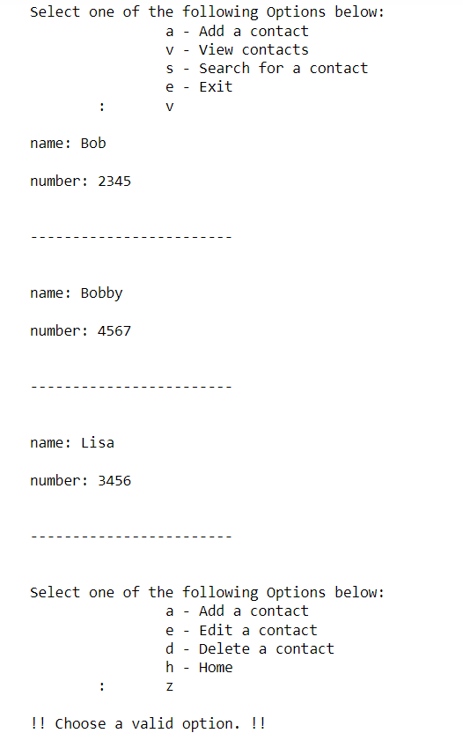

ADD CONTACT 2
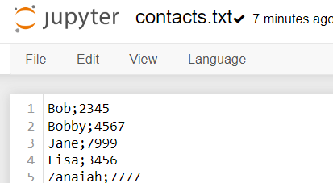

ADD CONTACT 3
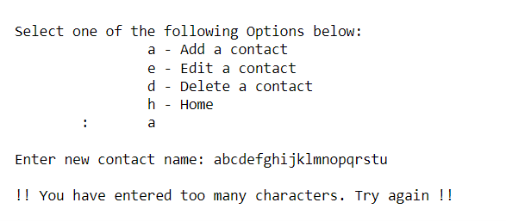

ADD CONTACT 4

ADD CONTACT 5

ADD CONTACT 6
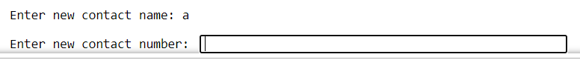
ADD CONTACT 7

ADD CONTACT 8
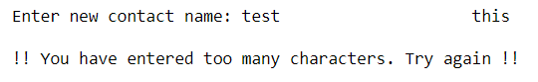
ADD CONTACT 9
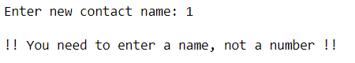
ADD CONTACT 10
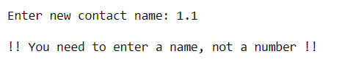
ADD CONTACT 11
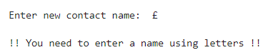
ADD CONTACT 12
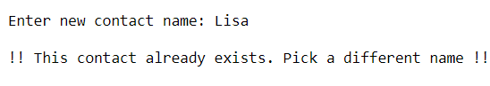

ADD CONTACT 13
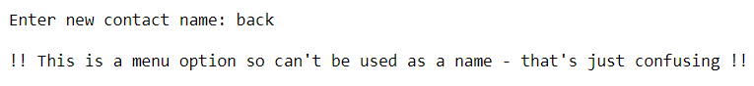
ADD CONTACT 14
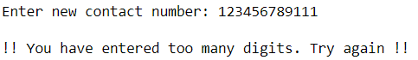
ADD CONTACT 15
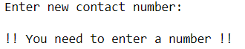
ADD CONTACT 16
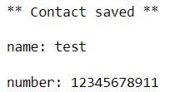
ADD CONTACT 17
ADD CONTACT 18
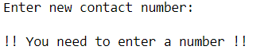
ADD CONTACT 19
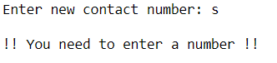
ADD CONTACT 20
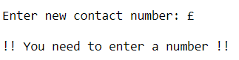
DELETE 2
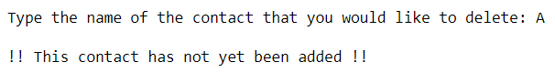
SEARCH 1
SEARCH 2

EDIT 1
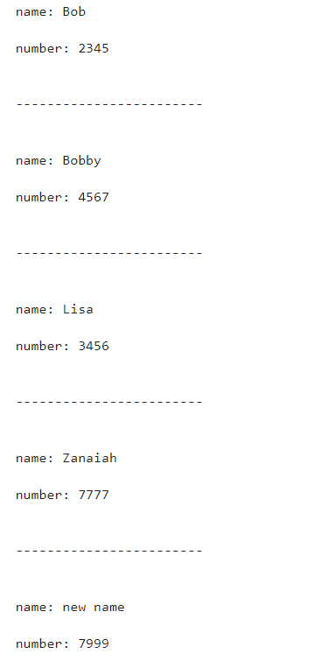
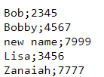

EDIT 2
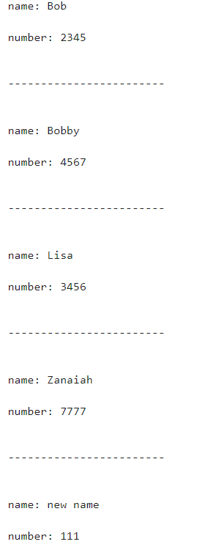
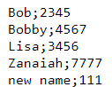

EDIT 3
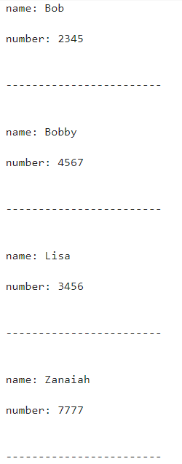
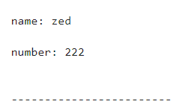
EMPTY LIST 1

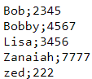

EMPTY LIST 1
